EXP. NO: 17 PERFORMANCE EVALUATION OF DIGITAL COMMUNICATION
SYSTEMS USING EYE DIAGRAM ANALYSIS UNDER ADDITIVE WHITE GAUSSIAN NOISE (AWGN) USING MATLAB

NAME:V.RUSHMITHA
DATE: 09/10/2026
Objectives
1. To generate a digital communication signal in MATLAB and transmit it through an
Additive White Gaussian Noise (AWGN) channel.
2. To obtain and analyze the eye diagram of the received digital signal for different noise
conditions.
3. To measure eye-opening parameters such as eye height, eye width, crossing level and
timing variation.
4. To study the effect of decreasing SNR / Eb/N0 on inter-symbol interference, noise margin
and timing performance.
5. To compare the transmitted and received signal characteristics and evaluate
communication-system performance.
Procedure
1. Open MATLAB and create a new script file.
2. Set the number of bits/symbols, samples per symbol, modulation scheme, symbol rate and sampling
parameters.
3. Generate a random binary sequence and map it to a digital waveform. For a basic experiment, use
BPSK with symbols −1 and +1.
4. Generate the transmitted waveform using an appropriate pulse-shaping method or rectangular NRZ
pulses.
5. Pass the waveform through an AWGN channel. Repeat the experiment for several SNR/Eb/N0
values, such as 20 dB, 10 dB, 5 dB and 0 dB.
6. Plot a portion of the transmitted and received waveforms in the time domain.
7. Construct the eye diagram by superimposing overlapping signal segments over two symbol periods.
8. Measure or estimate eye height, eye width, crossing level and timing uncertainty from the eye
diagram.
9. Compare the eye diagrams for different noise levels and observe the reduction in vertical and
horizontal eye opening.
10. Relate the observed eye-pattern changes to noise margin, sampling-time tolerance and probability
of symbol decision errors.
11. Record the results and calculate percentage deviation/error where a theoretical reference is
available.
PROGRAM (MATLAB CODE)
clc;
clear;
close all;
%% Parameters
N = 100; % Number of bits sps = 20; % Samples per symbol
SNR = 10; % Signal-to-Noise Ratio (dB)
%% Generate Random Binary Data
data = randi([0 1],1,N);
%% NRZ Encoding (0 -> 0, 1 -> 1)
tx_signal = repelem(data,sps);
%% Pass Signal through AWGN Channel
rx_signal = awgn(tx_signal,SNR,'measured');
%% Time Axis
t = (0:length(tx_signal)-1)/sps;
%% Plot Results
figure;
% Original Binary Data
subplot(4,1,1)
stairs(data,'LineWidth',1.5)
grid on
title('Original Binary Data')
xlabel('Bit Number')
ylabel('Bit')
ylim([-0.2 1.2])
% Transmitted NRZ Signal
subplot(4,1,2)
plot(t,tx_signal,'LineWidth',1.5)
grid on
title('Transmitted NRZ Signal')
xlabel('Time')
ylabel('Amplitude')
ylim([-0.5 1.5])
% Received Signal after AWGN
subplot(4,1,3)
plot(t,rx_signal,'r')
grid on
title(['Received Signal with AWGN (SNR = ',num2str(SNR),' dB)'])
xlabel('Time')
ylabel('Amplitude')
% Eye Diagram
subplot(4,1,4)
eyediagram(rx_signal,2*sps)
title('Eye Diagram of Received Signal')
OUTPUT GRAPH
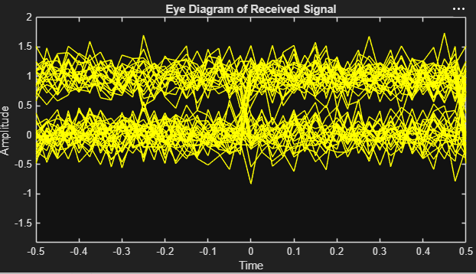
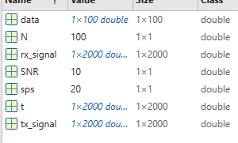
Result:
i) Successfully generated an NRZ digital communication signal and transmitted it through an
AWGN channel.
ii) Observed that the received signal was affected by Gaussian noise, resulting in signal
distortion and bit errors.
iii) Successfully plotted the eye diagram of the received signal using MATLAB.
iv) Observed that the eye opening decreased due to AWGN, indicating reduced signal quality
and increased probability of bit errors.

